SQL Queries For Project_customer_segmentation
- How is the shopping distribution according to gender?
SELECT gender, COUNT (*) AS total_customers FROM customer GROUP BY gender;
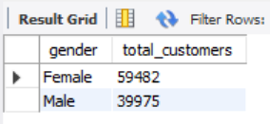
Insights:
The analysis indicates a nearly balanced participation between male and female shoppers, with a slight dominance of female customers.
This suggests that marketing efforts resonate more with women, who may exhibit higher engagement levels in retail activities.

- Which gender did we sell more products to?
SELECT gender, SUM (quantity) AS total_products FROM customer GROUP BY gender ORDER BY total_products DESC;
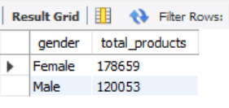
Insights:
Female customers accounted for a higher volume of product purchases compared to males.
This implies stronger purchase intent and possibly greater responsiveness to product variety and seasonal offers.

- Which gender generated more revenue?
SELECT gender, SUM (price*quantity) AS total_revenue FROM customer GROUP BY gender ORDER BY total_revenue DESC;
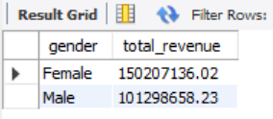
Insights:
Although both genders contribute significantly to overall sales, female shoppers generated slightly higher revenue.
This trend highlights their higher spending tendency and underlines the potential benefit of women-focused marketing strategies.

- Distribution of purchase categories relative to other columns?
- Gender wise category distribution
SELECT gender, category, COUNT (*) AS total_purchases FROM customer GROUP BY gender, category ORDER BY gender, total_purchases DESC;
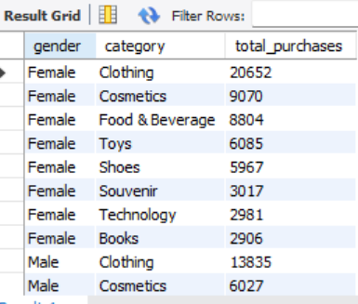
Insights:
Female customers show higher purchasing activity in categories like Clothing and Accessories, whereas male customers prefer Electronics and Gadgets.
This indicates gender-based variation in product preferences — females lean toward lifestyle items, while males focus on tech-oriented categories.

- Age Group wise category distribution
SELECT CASE
WHEN age < 20 THEN 'below 20'
WHEN age BETWEEN 20 AND 30 THEN '20-30'
WHEN age BETWEEN 31 AND 40 THEN '31-40'
WHEN age BETWEEN 41 AND 50 THEN '41-50'
WHEN age BETWEEN 51 AND 60 THEN '51-60'
ELSE '60+'
END AS age_group, category, COUNT(*) AS total_purchases FROM customer
GROUP BY age_group, category ORDER BY total_purchases DESC;
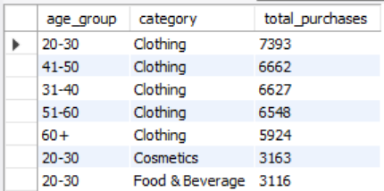
Insights:
Clothing and Cosmetics record the highest purchases across all age groups, with the 20-30 age group leading overall. Buying patterns suggest strong preference for fashion and personal care products.

- Payment method wise distribution
SELECT payment_method, category, COUNT (*) AS total_purchases FROM customer GROUP BY payment_method, category ORDER BY payment_method, total_purchases DESC;
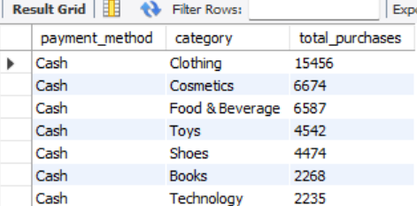
Insights:
Clothing emerged as the most purchased category across all age groups, with female customers aged 20–40 showing the highest activity.
Cash payments dominate overall transactions, indicating a customer preference for direct purchases over digital modes.
- How is the shopping distribution according to age?
SELECT CASE
WHEN age < 20 THEN 'below 20'
WHEN age BETWEEN 20 AND 30 THEN '20-30'
WHEN age BETWEEN 31 AND 40 THEN '31-40'
WHEN age BETWEEN 41 AND 50 THEN '41-50'
WHEN age BETWEEN 51 AND 60 THEN '51-60'
ELSE '60+'
END age_group, COUNT(*) AS transactions, SUM(quantity) AS total_items, SUM(quantity * price) AS total_revenue FROM customer GROUP BY age_group ORDER BY total_revenue DESC;
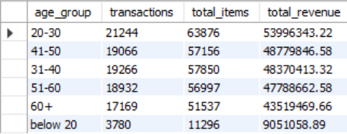
Insights:
The 20–30 age group dominates shopping activity with the highest transactions, items purchased, and revenue, showing they are the most active shoppers.
The 41–50 and 31–40 groups follow closely, reflecting strong purchasing power among middle-aged customers.
The below-20 segment contributes the least, indicating minimal engagement or limited spending capacity.

- Which age cat did we sell more products to?
SELECT CASE
WHEN age < 20 THEN 'below 20'
WHEN age BETWEEN 20 AND 30 THEN '20-30'
WHEN age BETWEEN 31 AND 40 THEN '31-40'
WHEN age BETWEEN 41 AND 50 THEN '41-50'
WHEN age BETWEEN 51 AND 60 THEN '51-60'
ELSE '60+'
END AS age_group, SUM(quantity) AS total_products_sold
FROM customer GROUP BY age_group ORDER BY total_products_sold DESC;
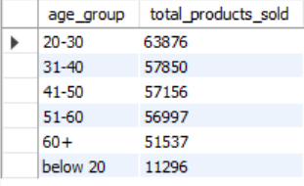

Insight:
The 20–30 age group purchased the highest number of products, highlighting their dominant shopping activity across categories.
- Which age cat generated more revenue?
SELECT
CASE
WHEN age < 20 THEN 'below 20'
WHEN age BETWEEN 20 AND 30 THEN '20-30'
WHEN age BETWEEN 31 AND 40 THEN '31-40'
WHEN age BETWEEN 41 AND 50 THEN '41-50'
WHEN age BETWEEN 51 AND 60 THEN '51-60'
ELSE '60+'
END AS age_group, SUM(price * quantity) AS total_revenue FROM customer GROUP BY age_group ORDER BY total_revenue DESC;
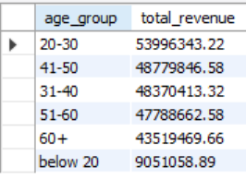
Insights:
The 20–30 age group generated the highest revenue, indicating they are the most profitable customer segment. Middle-aged groups (31–50) also show strong spending capacity, while customers below 20 contribute the least to overall revenue.

- Distribution of purchase categories relative to other columns?
- Category vs Gender
SELECT gender, category, COUNT (*) AS total_purchases FROM customer
GROUP BY gender, category ORDER BY total_purchases DESC;
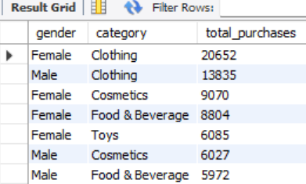

- Category vs Agegroup
SELECT CASE
WHEN age < 20 THEN 'below 20'
WHEN age BETWEEN 20 AND 30 THEN '20-30'
WHEN age BETWEEN 31 AND 40 THEN '31-40'
WHEN age BETWEEN 41 AND 50 THEN '41-50'
WHEN age BETWEEN 51 AND 60 THEN '51-60'
ELSE '60+'
END AS age_group, category, COUNT(*) AS total_purchases FROM customer
GROUP BY age_group, category ORDER BY total_purchases DESC;
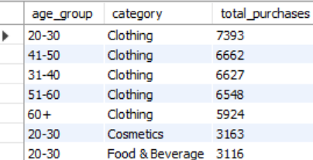

- Category vs Payment Method
SELECT payment_method, category, COUNT(*) AS total_purchases FROM customer GROUP BY payment_method, category ORDER BY total_purchases DESC;
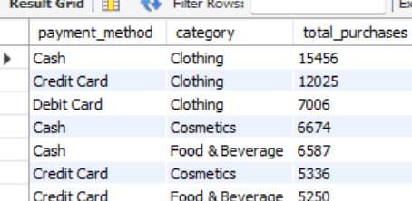
Insights:
Female customers lead in overall purchases, especially in Clothing and Cosmetics, indicating stronger retail engagement among women.
Across all age groups, Clothing remains the most purchased category, showing consistent consumer demand for apparel regardless of age.
Younger adults (20–40) dominate purchase activity, suggesting higher spending power and brand responsiveness in this segment.
Cash is the most used payment method across categories, but Credit Cards are significantly preferred for Clothing and Cosmetics, hinting at growing digital payment adoption for higher-value retail items.

- Does the payment method have a relation with other columns?
- Payment Method vs Gender
SELECT gender, payment_method, COUNT(*) AS total_transactions FROM customer GROUP BY gender, payment_method ORDER BY total_transactions DESC;
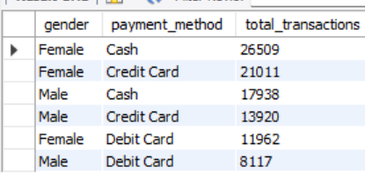
- Payment Method vs Age Group
SELECT CASE
WHEN age < 20 THEN 'below 20'
WHEN age BETWEEN 20 AND 30 THEN '20-30'
WHEN age BETWEEN 31 AND 40 THEN '31-40'
WHEN age BETWEEN 41 AND 50 THEN '41-50'
WHEN age BETWEEN 51 AND 60 THEN '51-60'
ELSE '60+'
END AS age_group, payment_method, COUNT(*) AS total_transactions FROM customer
GROUP BY age_group, payment_method ORDER BY total_transactions DESC;
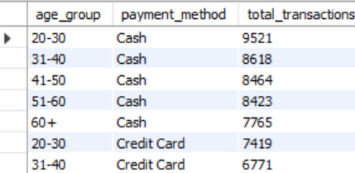

- Payment Method vs Purchase Category
SELECT payment_method, category, COUNT(*) AS total_transactions FROM customer
GROUP BY payment_method, category ORDER BY total_transactions DESC;
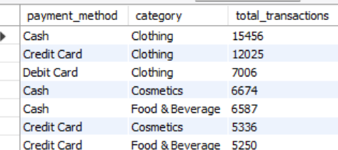
Insights:
Female customers dominate transactions across all payment methods, showing higher overall engagement, with cash and credit cards being their top choices.
Across age groups, cash remains the most preferred payment method, especially among customers aged 20–40, indicating a continued reliance on traditional payments.
Credit card usage is increasing among younger segments, reflecting growing digital adoption and financial literacy.
In terms of purchase categories, clothing drives the highest transactions across all payment types, particularly via cash and credit card.
Overall, the data reveals strong cash dependency but emerging trends toward digital payments, particularly among younger and female customers.

- How is the distribution of the payment method?
SELECT payment_method, COUNT(*) AS total_transactions FROM customer
GROUP BY payment_method ORDER BY total_transactions DESC;
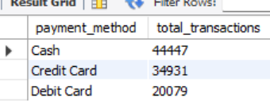
Insights: The analysis shows that Cash is the most widely used payment method, followed by Credit Card and Debit Card.This indicates a strong preference for Cash transactions among customers.

